Andres Gamez
GEOG 30333.045
Dr. Crotty
10/11/24
Professional Assignment 1
Super-Cool Commercial Real Estate Firm
North Central Texas has a sprawling real estate market that offers great opportunity for residents moving into the area or moving throughout it. The key demographic I have selected for investigation is individuals over 65, or those considered elderly. The four communities I identified as having the highest continuous zones of concentration for high percentages of population over 65 are: North of University Park, Central Fort Worth, Western Plano, and Rockwall (Figure 1). Each of these sites was selected because they have large continuous tracts of high percentages of individuals over 65 and also feature the infrastructure that is necessary for residents of these communities to age-in place. The infrastructure points being Hospitals, Urgent Care, Fire Stations, Police Stations, Shopping Centers, Parks, and Highways.
The first site of elderly supportive infrastructure in North Central Texas is the neighborhoods North of University Park in Dallas (Figure 2). There are 8 census tracts that have more than 33 percent of their populations over 65. This site is a suitable location as it has a higher density of these populations and the infrastructure to support these communities. It has easily accessible transportation networks in the form of major and minor highways, a number of urgent care facilities and hospitals close to deal with possible health emergencies, and parks for leisure and gathering. It also features public services such as police and fire stations prominently accessible to the community. The abundance of services in this area in terms of all these metrics makes it an ideal site.
The second site of elderly supportive infrastructure in North Central Texas is the Upper West Side & Medical District of Fort Worth (Figure 3). This area is smaller than the previous site and offers only 1 census tract with a population above 33% over 65, and 1 tract with a population over 65 percentage from 20-32%. For its smaller spatial extent this area offers all of the essential services within a relatively dense area, albeit within short distances. The main point of attraction for this area is its centering around the Medical District of Fort Worth, the area with the highest concentration of Hospitals in Fort Worth, making it an attractive area for elderly or chronically ill persons. The distribution of associated amenities seems to not be as concentrated but there is still a large availability of them. Park size is not represented in this visualization but some of the largest parks in the cities are located in this area, such as Trinity Park. The fire and police stations are similarly not as dense but there is multiple of each within the area to assist in emergency situations.
The third site of elderly supportive infrastructure in North Central Texas is in Western Plano (Figure 4). Within this area there are 2 census tracts that have over 33% of their population as over 65, with 10 tracts that have 20-32% of their populations over 65. The extent of this visualization covers a larger area so includes a wider array of these infrastructure points. This area has a large number of parks for recreation, followed by a good number of hospitals although they are more widespread, with several fire and police stations. While there is overall a larger number of these infrastructure points there are less major transportation conduits with only two highways, with one running North-South and the other running East-West. So, there is a good amount of infrastructure points, but they are spread out in a less accessible way. Given the concentration of these points in the areas this would make a suitable site for selection.
The fourth site of elderly support infrastructure in North Central Texas is Rockwall (Figure 5). Rockwall is a smaller community but its density of support infrastructure and counts of 2 census tracts that have above 20% of their population above 65 make it a strong site. The proximity of these tracts to areas of high support infrastructure density make it an attractive site candidate. The concentration of hospitals and urgent care to the south, central, and north Rockwall areas create a web of healthcare accessibility. The high concentration of police and fire stations in the central Rockwall area will be desirable for providing a sense of security to elderly residents. Overall while there is fewer areas with high elderly percentages there is an dense infrastructure present for more individuals to age-in place.
I ran these analyses off of several sets of data, from the North Central Texas Council of Governments (NCTCOG) and from the U.S. Census Bureau. The layers I used from NCTCOG covered: the counties in the NCTCOG and their census tracts, Highways in the NCTCOG counties, and the feature data for infrastructure points across the counties within NCTCOG. The second source of data I used was the American Community Survey 5-Year Estimates from the U.S. Census Bureau, packaged and downloaded with the TIGER/Line Select Economic and Demographic Data tool.
I began my analysis by downloading these datasets and importing them into ArcGIS Pro. I ran my first analysis by pulling the layer for the census tracts within the NCTCOG. I then imported the ACS data for all of Texas in 2020. I then ran a select by location search for only the NCTCOG tracts present in the ACS dataset and was able to export a new layer of ACS datapoints that only featured the NCTCOG tracts. I then drew the Age & Sex data from the ACS data and ran a join to that dataset to the NCTCOG tracts layer along the GEOID_data and GEOID fields. From here I had one layer of all the NCTCOG census tracts that contained all the 2020 ACS Sex & Age data. I then looked at the ACS Metadata to identify the fields in the Age & Sex table that were the most relevant to my analysis. I identified the field B1001e1 as the total population estimate and a range of fields for male and females over 65, those being B01001e44-e49 and B01001e20-e25. Since I needed a singular number representative of all genders and all people over 65 in each census tract, I ran a calculation to add up all the values of these fields. I then produced the field Pop_Over_65 which counted the full population of each census tract over 65. I then ran a separate analysis of Pop_Over_65 / B1001e1 to produce a field that represented the percentage of the population that is over 65 in each census tract, that field being Pct_Over_65. I then used this new field to visualize the percentage of people over 65 in each census tract in North Central Texas. I then enacted a number of cartographic principles and practices to create the map “Percent of Elderly Population in North Central Texas. (Figure 1)”
To visualize infrastructure features I imported the NCTCOG Features (2024) dataset into ArcGIS Pro. I then opened up the symbology panel and manually removed all the feature types that did not pertain to elderly support infrastructure. I chose: Urgent Care, Hospitals, Fire and Police Stations, Parks, and Shops after doing some independent research and learned that those areas best represented the most common services that the elderly are in need of. I chose to represent these points as Unique Values so each infrastructure type would have its own point, I then manually configured the feature points of each infrastructure type to visually represent what class of service they fell into. I also added in feature highway data to depict transportation flows, as there is little public transportation across North Central Texas the most likely was the elderly commute to places is driving, either by themselves if they are still able or being driven by a family member, close friend, or living assistant.
I used the maps produced by these methods of analysis and created 5 map layouts (Figs 1-5), each a different map portraying the data at large and 4 sites of interest (Figs 2-5). These layouts were created by the insertion of two distinct map frames, one containing the age and infrastructure data, and one map inset each containing only the percentage age data to show the broader area of the sites. To create the inset maps, I had to create copies of the original map layout and exclude the infrastructure data points as they clouded the view of all else in the inset maps.
All 5 of the map layouts are fairly similar in their composition and layout. I began map construction back in the earlier portion of my analysis when I was assessing the percentage of elderly individuals in each census tract. I chose to visualize this data with a Choropleth map as I felt that best represented the difference of these percents within their census tracts. I used the Jenks breaks to separate the categories because as shown by the histogram of counts of tracts in each bin there is a larger amount of tracts with smaller numbers so allowing ArcGis to break it down automatically allowed for a more balanced dispersal of the colors on the map. I used a color scheme that was visually striking for the tracts with the highest percentages to draw the eye to these tracts (Figure 1). This map served as the base map for the features and inset maps on each layout. For the map “Percent of Elderly Population in North Central Texas” I displayed the whole map of all the counties within NCTCOG and provided basic reference information such as the legend, north compass, scale bar, title, and a description of the map (Figure 1). These basic features were used in all of my map layouts, with small variances in the legends and display of the inset maps, and titles. These choices were made to keep the appearance of the maps consistent with each other. The main point of difference for some of the maps is how those for sites 2 and 4 are vertically laid out rather than horizontally (Figure 3 & 5). This was done because of the shape of the census tracts being visualized, as the features being displayed were spread out more North/South than East/West as with the other map layouts. The location of elements on each map varies a bit as they were placed in the legend box and along the map to maximize visual balance appeal and not cover any of the most important map features, so placement of individual elements varies heavily but he appearance of them is standard. The primary difference between each map is the scale used for the scale of the maps. For “Percent of Elderly Population in North Central Texas” a scale of 1:1,200,000 was used (Fig 1). For site 1 a scale of 1:64,000 was used (Fig 2). For site 2 a scale of 1:21,000 was used (Fig 3). For site 3 a scale of 1:45,000 was used (Fig 4). For site 4 a scale of 1:68,000 was used (Fig 5). This variance of scale was used to focus the maps only on the localities being promoted by them and not reach too far beyond the target neighborhoods so were selected on a site-by-site basis. These decisions were all taken to maximize the visual impact of the argument being communicated by each map that each of these sites should be selected by Super-Cool Commercial Real Estate Firm to develop.
Figures: 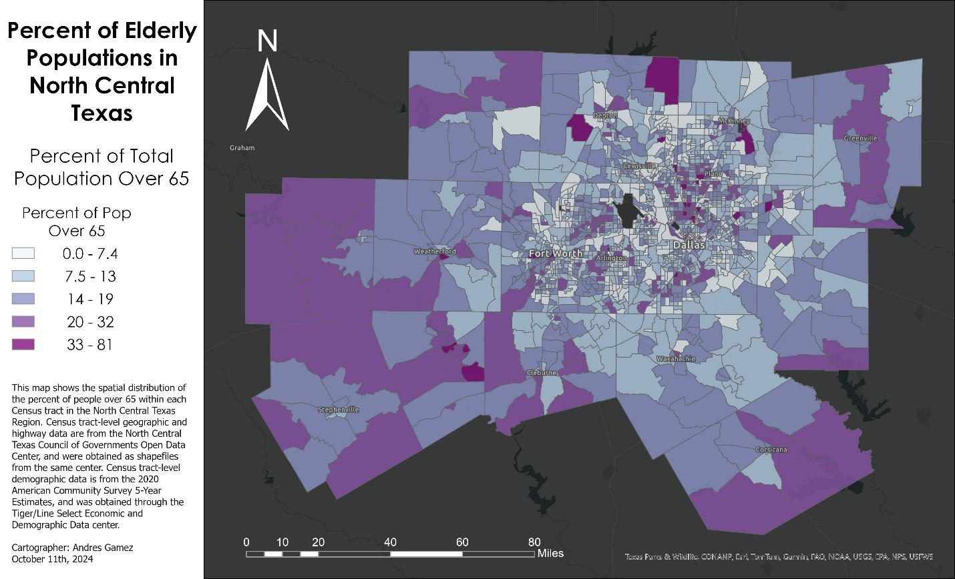
Figure 1: “Percent of Elderly Populations in North Central Texas”
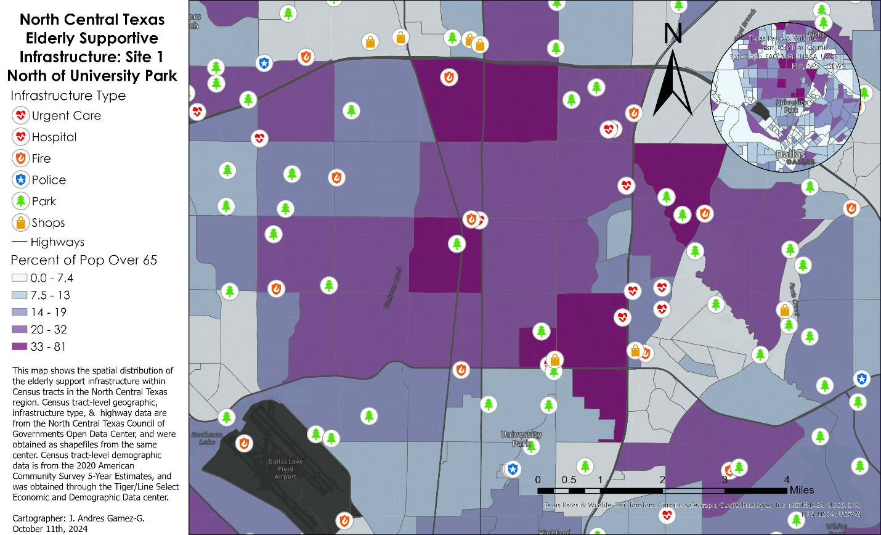
Figure 2: “North Central Texas Elderly Supportive Infrastructure: Site 1: North of University Park”
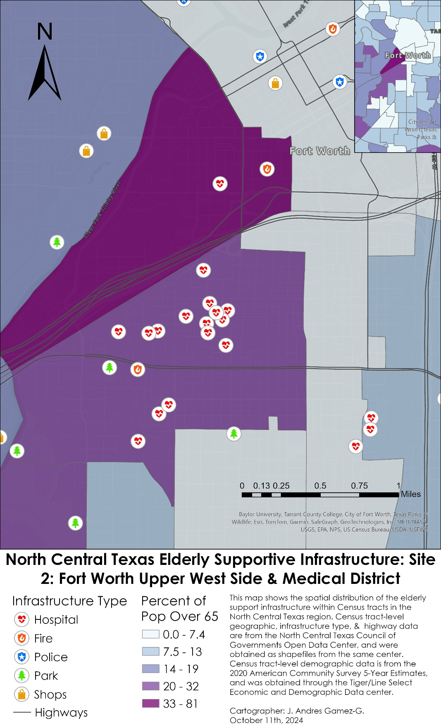
Figure 3: North Central Texas Elderly Supportive Infrastructure: Site 2: Fort Worth Upper West Side & Medical District”
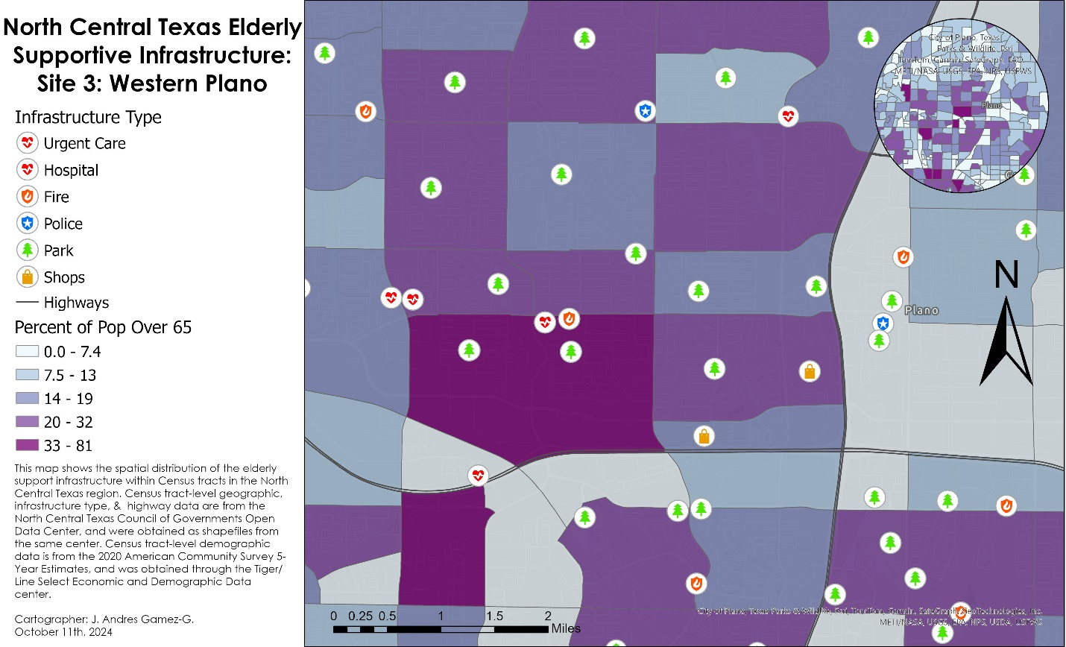
Figure 4: North Central Texas Elderly Supportive Infrastructure: Site 3: Western Plano”
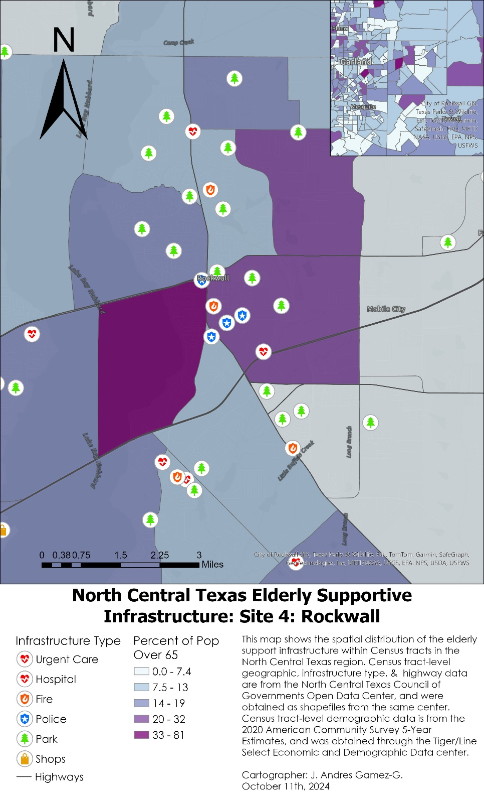
Figure 5: North Central Texas Elderly Supportive Infrastructure: Site 4: Rockwall”

